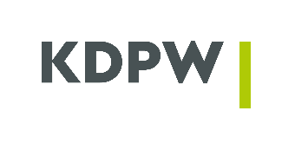 |  | Model instruction referred to in § 9(4) of the ARM Rules
New | Modification |  |  | Cancellation
Production | Test |  | Effective date _ _ _ _-_ _-_ _
Instruction to build ARM organised market reports
Scope of instruction
- ARM Participant

Institution code

Participant LEI

Participant name _______________________________________________________________________________________________

- Market for which ARM is to build reports
Consent*
X | W | A | R | GPW spot regulated market (main) | YES/NO
MIC
W | B | O | N | GPW bond market Catalyst – main market | YES/NO
MIC
W | M | T | F | GPW bond market Catalyst – MTF | YES/NO
MIC
W | E | T | P | GPW ETF and structured instrument market | YES/NO
MIC
W | D | E | R | GPW derivatives regulated market | YES/NO
MIC
X | N | C | O | GPW ATS - NewConnect | YES/NO
MIC
R | P | W | C | BondSpot regulated market (main)** | YES/NO
MIC
B | O | S | P | BondSpot ATS** | YES/NO
MIC
X | O | F | F | Off-market trade – listed instruments | YES/NO
MIC
X | G | L | O | GPW ATS – GlobalConnect | YES/NO
MIC

* Delete as appropriate
** Active since the implementation of the WATS system

The ARM participant submitting this instruction gives consent for KDPW to build trade reports on the basis of data received by KDPW from the organised market and supplementary messages sent by the participant and then transmit such data to the competent Supervisor in the form of a report as referred to in § 12(1) of the ARM Rules.
KDPW Participant giving consent
______________________________________
Date, Name, Signatures of authorised representatives

